Project Title
Task Manager Web Application

Abstract
The Task Manager Web Application is a web-based project developed to help users organize and manage their daily tasks efficiently.
The application provides a simple and interactive interface where users can add and view tasks, helping them improve productivity and time management.

Project Overview
This project focuses on developing a modern task management system using frontend web technologies.
Instead of manual task tracking, the application offers a digital solution that allows users to manage tasks in an organized and user-friendly manner.
The main objective of this project is to design a responsive and efficient web application with a clean user interface.

Features
- Create and manage daily tasks
- Clear and organized task display
- User-friendly and responsive interface
- Fast and smooth application performance

Tools and Technologies Used
- HTML – Used for structuring the web pages
- CSS & Tailwind CSS – Used for styling and responsive design
- React.js – Used for building reusable UI components
- Vite – Used as a fast development and build tool
- JavaScript / TypeScript – Used for application logic

Applications
- Personal task management
- Student academic task tracking
- Daily activity organization
Demo video :
LINK :
https://drive.google.com/file/d/1Y2P4IBhl4uXcJbnBwqdrZ7XIQulyiGz/view?usp=sharing

Demo pictures:
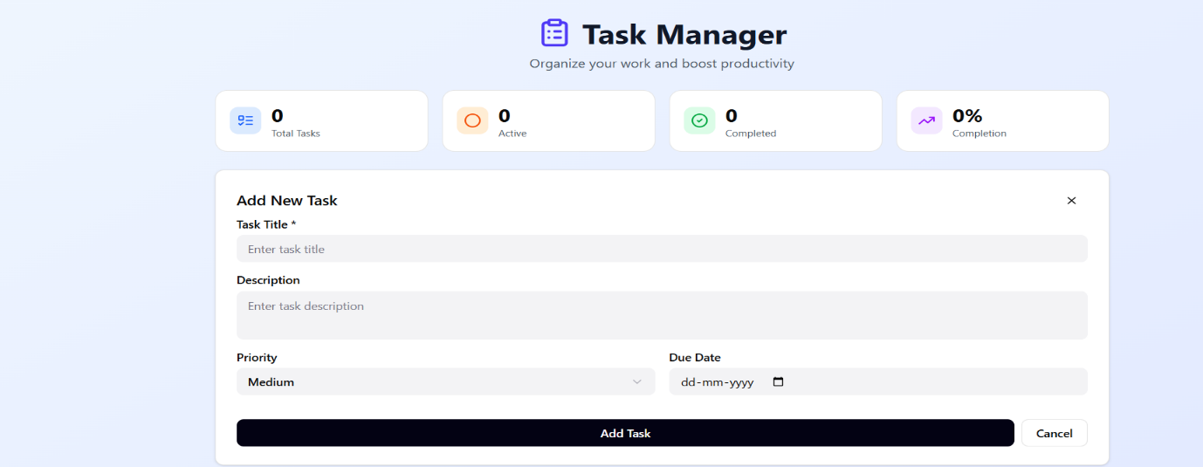
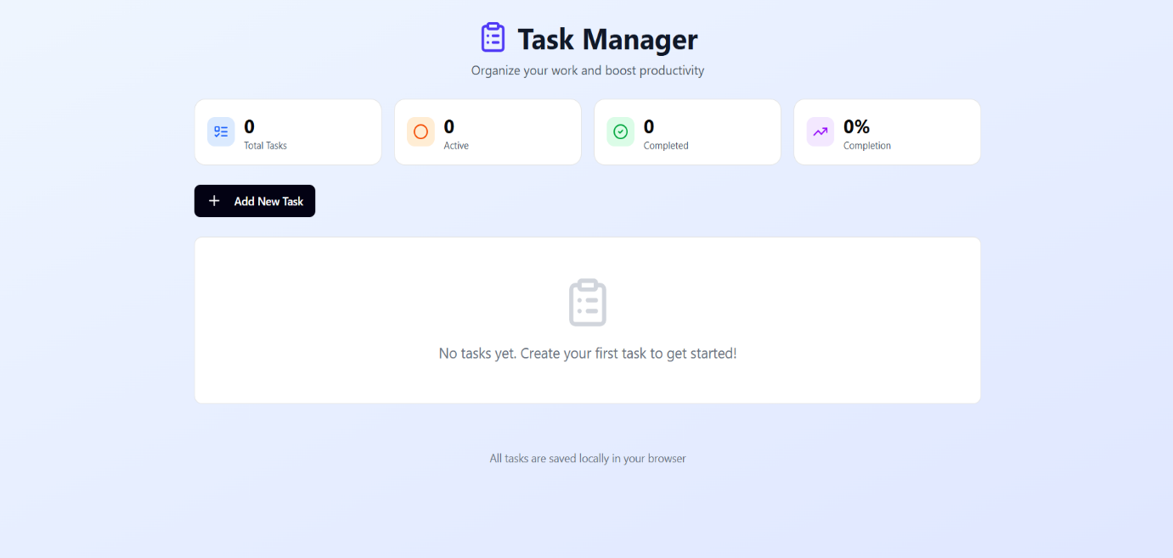
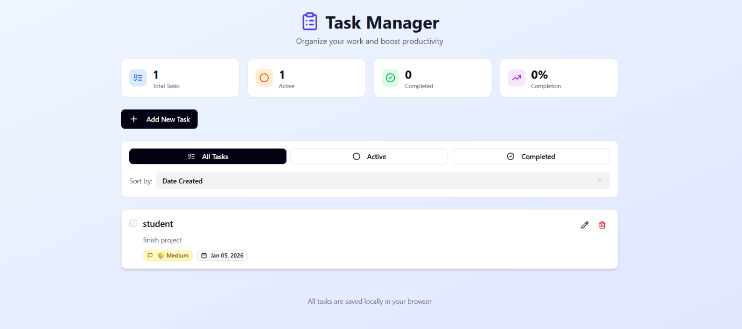
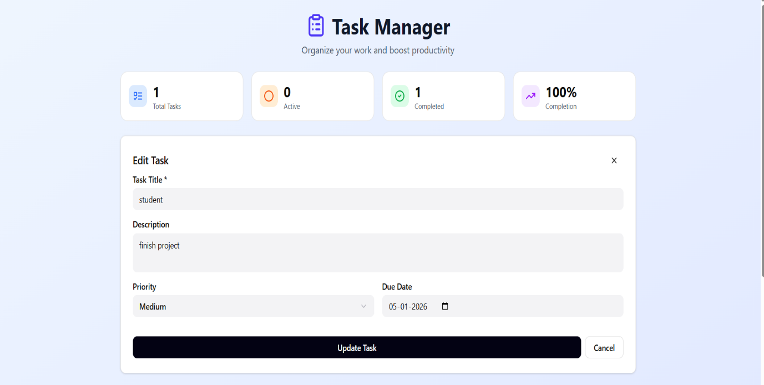

Conclusion
The Task Manager Web Application is a simple and effective solution for managing daily tasks.
This project helped in gaining practical knowledge of frontend development and modern web technologies.
It also enhanced skills in UI design, component-based development, and responsive web design.

